**ABSTRACT**

This report presents a comprehensive structural analysis of a spur gear subjected to different loads using the finite element method in ANSYS. The study aims to evaluate the gear's mechanical behaviour, stress distribution, and deformation under various operating conditions. The analysis considers multiple load cases, including tangential, radial, and axial loads, as well as combined load scenarios. The results show the gear's stress concentration, deformation patterns, and potential failure modes under each load case. The study also investigates the effects of gear geometry, material properties, and loading conditions on the structural performance. The findings provide valuable insights for designers and engineers to optimize gear design, select suitable materials, and ensure reliable operation under diverse loading conditions. The results demonstrate the effectiveness of ANSYS in simulating real-world gear performance and facilitating informed design decisions.

Spur gears are crucial components in mechanical power transmission systems, and their structural integrity is vital for efficient and reliable operation. This research presents an in-depth structural analysis of a spur gear using ANSYS software, examining its behaviour under diverse loading conditions. A 3D model of the spur gear was created and discretized into finite elements using ANSYS Workbench.

Static structural analyses were conducted for three distinct load cases: (1) tangential load, simulating torque transmission; (2) radial load, mimicking gear meshing forces; and (3) combined tangential and radial loads, representing real-world operating conditions. The results indicate that tangential loading induces maximum stress concentrations at the gear tooth root and fillet regions, potentially leading to tooth fracture. Radial loading causes significant deformation and stress in the gear web and hub regions.

The combined load case exhibits a complex stress distribution, with high stress concentrations at the tooth-root fillet and web-hub junctions, posing a risk of gear failure. A parametric study was conducted to investigate the influence of gear material properties on structural behaviour. The results show that gear materials with higher Young's modulus and yield strength exhibit improved structural performance, highlighting the importance of material selection in gear design.

The study also examined the effect of gear geometry on structural behaviour, revealing that gear teeth with optimized geometry exhibit reduced stress concentrations and improved load-carrying capacity. The findings of this research provide valuable insights for designers, engineers, and researchers to optimize spur gear design, select appropriate materials, predict gear behaviour, and improve gear reliability.

The comprehensive analysis demonstrates the effectiveness of ANSYS in analysing complex gear structures and provides a foundation for future research on gear design optimization, material selection, and failure prediction. By understanding the structural behaviour of spur gears under various loads, industries can enhance gear performance, reduce maintenance costs, and improve overall system efficiency. The results of this study contribute to the development of more efficient, reliable, and durable gear transmission systems.

|  |  |
| --- | --- |
| ***CONTEXTS*** | **PAGE NO** |
| **Introduction to Gears**  **1.1Historical Background:**  **1.2Importance of Gears:**  **1.3Gear Terminology Understanding the Language**  **1.4 Gear Materials and Manufacturing:**  **1.5Manufacturing processes have evolved to meet the demands of modern gear production:**  **1.6Applications of Gears: Powering Innovation**  **2.Types of Gears**  **2.1A Diverse Range of Applications**  **2.2Material selection for gears**  **2.3When selecting a material for gears and spur gears, consider the following factors:**  **2.4For spur gears specifically, additional considerations include:**  **3.ANSYS**  **3.2ANSYS enables engineers and researchers to:**  **3.3ANSYS is widely used in various industries, including:**  **3.4Some of the key benefits of using ANSYS include:**  **3.4ANSYS offers a range of products and modules, including:** |  |
| ***CONTEXTS***  **TABLE 1**  **TABLE 2**  **TABLE 4**  **TABLE 5**  **TABLE 6**  **TABLE 7**  **TABLE 8**  **TABLE 9**  **TABLE 10**  **TABLE 12**  **TABLE 13**  **TABLE 14**  **TABLE 15**  **TABLE 16**  **TABLE 17**  **TABLE 18**  **TABLE 19**  **TABLE 20**  **TABLE 21**  **TABLE 22**  **TABLE 23**  **TABLE 24**  **TABLE 25**  **TABLE 26**  **TABLE 27** |  |

**1.Introduction to Gears**

Gears are a crucial component in modern machinery, playing a vital role in transmitting power and motion between rotating shafts. With a history dating back to ancient civilizations, gears have evolved significantly over time, adapting to the demands of technological advancements and industrial growth. Today, gears are a fundamental element in various industries, including automotive, aerospace, robotics, and manufacturing.

1.1Historical Background:

The earliest recorded use of gears dates back to ancient Greece, around 300 BCE, with the Antikythera mechanism, an intricate astronomical calculator. This ancient marvel utilized gears to track celestial movements, demonstrating the ingenuity of our ancestors. As civilizations rose and fell, gear technology continued to advance, with significant contributions from ancient Chinese, Arabic, and European inventors. The Industrial Revolution marked a significant turning point, as gears became a crucial component in mechanized manufacturing, transportation, and machinery.

1.2Importance of Gears:

Gears are essential in modern technology, offering numerous benefits, including:

- Efficient power transmission

- Precise motion control

- High torque density

- Compact design

- Low noise and vibration

1.3Gear Terminology: Understanding the Language

Familiarity with gear terminology is essential for effective communication and design:

1. Pitch Circle: The circle passing through gear teeth centres, defining the gear's diameter and tooth size.

2. Pitch Diameter: The diameter of the pitch circle, influencing gear ratio and speed.

3. Module: The ratio of pitch diameter to number of teeth, determining gear strength and durability.

4. Tooth Width: The distance between tooth faces, affecting gear engagement and load distribution.

5. Pressure Angle: The angle between tooth face and radial line, impacting gear efficiency and noise.

**1.4 Gear Materials and Manufacturing:**

A Balance of Strength and Cost

Gears are crafted from a variety of materials, each offering unique benefits and trade-offs:

1. Steel: High-strength, low-cost, and widely available, making it a popular choice for industrial gears.

2. Aluminium: Lightweight, corrosion-resistant, and ideal for high-speed applications.

3. Cast Iron: Durable, wear-resistant, and suitable for heavy-duty machinery.

4. Copper: Conductive, corrosion-resistant, and employed in specialized applications.

1.5Manufacturing processes have evolved to meet the demands of modern gear production:

1. Machining: Precise, high-speed cutting for complex gear geometries.

2. Casting: Cost-effective, high-volume production for simple gear designs.

3. Forging: High-strength, low-cost production for critical gear components.

4. 3D Printing: Rapid prototyping and production for complex, customized gears.

1.6Applications of Gears: Powering Innovation

Gears are ubiquitous in modern technology, driving innovation and progress in:

1. Automotive Transmissions: Efficient, high-performance gearing for vehicles.

2. Aerospace Propulsion: Precise, high-reliability gearing for aircraft and spacecraft.

3. Robotics and Mechatronics: Compact, high-torque gearing for precision motion.

4. Industrial Machinery: Heavy-duty, high-efficiency gearing for manufacturing and processing.

5. Wind Turbines and Renewable Energy: Reliable, high-torque gearing for sustainable power generation.

In conclusion, gears are the backbone of mechanical power transmission, enabling efficient energy transfer and precise motion control. Understanding gear fundamentals, types, terminology, materials, and applications is essential for designing and optimizing gear systems, driving innovation and progress in various industries.

**2.Types of Gears**

2.1A Diverse Range of Applications

Gears come in various shapes, sizes, and configurations, each designed to address specific challenges and applications:

1. Spur Gears: Straight-toothed gears for parallel shafts, widely used in industrial machinery and automotive transmissions.

2. Helical Gears: Angled-toothed gears for parallel or non-parallel shafts, offering improved load-carrying capacity and reduced noise.

3. Bevel Gears: Conical gears for intersecting shafts, essential in differential systems and robotics.

4. Worm Gears: Screw-like gears for perpendicular shafts, commonly used in heavy-duty applications and precision machinery.

5. Planetary Gears: Compact, high-ratio gears for complex motion, employed in aerospace, robotics, and high-performance transmissions.

Material selection for gears and spur gears is critical to ensure optimal performance, durability, and reliability. Here are some common materials used for gears and spur gears:

2.2Material selection for gears

1. Steel:

- Alloy steels

- Stainless steels

- Carbon steels

2. Cast Iron:

- Gray cast iron

- Ductile cast iron

3. Non-ferrous metals:

- Aluminum alloys

- Copper alloys

- Titanium alloys

4. Plastics:

- Nylon

- Polyacetal (POM)

- Polycarbonate (PC)

5. Hybrid materials:

- Steel-plastic composites

- Carbon fiber reinforced polymers (CFRP)

2.3When selecting a material for gears and spur gears, consider the following factors:

1. Strength and durability

2. Wear resistance

3. Corrosion resistance

4. Fatigue resistance

5. Cost and availability

6. Machinability and manufacturability

7. Operating temperature range

8. Environmental conditions (e.g., humidity, chemicals)

2.4For spur gears specifically, additional considerations include:

1. Tooth strength and durability

2. Surface finish and roughness

3. Gear tooth geometry and accuracy

4. Pitch line velocity and speed

Ultimately, the chosen material should balance performance, cost, and manufacturing requirements for the specific application.

**3.ANSYS**

3.1ANSYS is a powerful engineering simulation software used for analyzing and predicting the behavior of complex systems and products. It offers a comprehensive suite of tools for:

1. Structural analysis (mechanical, thermal, and fluid flow)

2. Fluid dynamics (CFD)

3. Heat transfer

4. Electromagnetics

5. Multiphysics simulations

3.2ANSYS enables engineers and researchers to:

1. Model complex geometries and systems

2. Simulate real-world conditions and scenarios

3. Analyze and predict performance, stress, and deformation

4. Optimize designs and materials

5. Reduce prototyping and testing costs

3.3ANSYS is widely used in various industries, including:

1. Aerospace and defense

2. Automotive

3. Energy and utilities

4. Healthcare and medical devices

5. Industrial equipment and machinery

6. Sports and consumer products

3.4Some of the key benefits of using ANSYS include:

1. Improved product performance and reliability

2. Reduced design and development time

3. Enhanced collaboration and communication

4. Increased innovation and competitiveness

5. Better decision-making through simulation-driven insights

3.4ANSYS offers a range of products and modules, including:

1. ANSYS Mechanical

2. ANSYS CFD

3. ANSYS Electromagnetics

4. ANSYS Multiphysics

5. ANSYS Workbench

6. ANSYS Fluent

7. ANSYS Maxwell

**FIGURE 1.0**

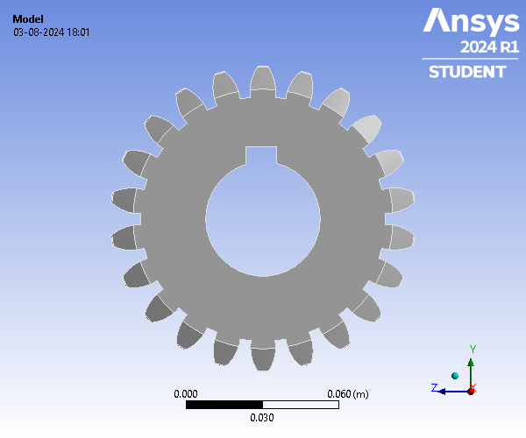

**Contents**

* **Units**
* **Model (A4)**
  + Geometry Imports
    - Geometry Import (A3)
  + Geometry
    - Spur Gear
  + Materials
  + Coordinate Systems
  + Mesh
  + **Static Structural (A5)**
    - Analysis Settings
    - Loads
    - Solution (A6)
      * Solution Information
      * Results
* **Material Data**
  + Structural Steel

**Units**

**TABLE 1**

**Model (A4)**

|  |  |
| --- | --- |
| Unit System | Metric (m, kg, N, s, V, A) Degrees rad/s Celsius |
| Angle | Degrees |
| Rotational Velocity | rad/s |
| Temperature | Celsius |

**TABLE 2  
Model (A4) > Geometry Imports**

|  |  |
| --- | --- |
| Object Name | *Geometry Imports* |
| State | Solved |

**TABLE 3  
Model (A4) > Geometry Imports > Geometry Import (A3)**

|  |  |
| --- | --- |
| Object Name | *Geometry Import (A3)* |
| State | Solved |
| **Definition** | |
| Source | C:\Users\vishn\AppData\Local\Temp\WB_vishn_13116_2\wbnew_files\dp0\SYS\DM\SYS.agdb |
| Type | DesignModeler |
| **Basic Geometry Options** | |
| Parameters | Independent |
| Parameter Key |  |
| **Advanced Geometry Options** | |
| Compare Parts On Update | No |
| Analysis Type | 3-D |

***Geometry***

**TABLE 4  
Model (A4) > Geometry**

|  |  |
| --- | --- |
| Object Name | *Geometry* |
| State | Fully Defined |
| **Definition** | |
| Source | C:\Users\vishn\AppData\Local\Temp\WB_vishn_13116_2\wbnew_files\dp0\SYS\DM\SYS.agdb |
| Type | DesignModeler |
| Length Unit | Meters |
| Element Control | Program Controlled |
| Display Style | Body Color |
| **Bounding Box** | |
| Length X | 3.e-002 m |
| Length Y | 0.12006 m |
| Length Z | 0.1194 m |
| **Properties** | |
| Volume | 2.2937e-004 m³ |
| Mass | 1.8006 kg |
| Scale Factor Value | 1. |
| **Statistics** | |
| Bodies | 1 |
| Active Bodies | 1 |
| Nodes | 7375 |
| Elements | 3703 |
|  |  |
| Mesh Metric | None |
| **Update Options** | |
| Assign Default Material | No |
| **Basic Geometry Options** | |
| Parameters | Independent |
| Parameter Key |  |
| Attributes | Yes |
| Attribute Key |  |
| Named Selections | Yes |
| Named Selection Key |  |
| Material Properties | Yes |
| **Advanced Geometry Options** | |
| Use Associativity | Yes |
| Coordinate Systems | Yes |
| Coordinate System Key |  |
| Reader Mode Saves Updated File | No |
| Use Instances | Yes |
| Smart CAD Update | Yes |
| Compare Parts On Update | No |
| Analysis Type | 3-D |
| Import Facet Quality | Source |
| Clean Bodies On Import | No |
| Stitch Surfaces On Import | None |
| Decompose Disjoint Geometry | Yes |
| Enclosure and Symmetry Processing | Yes |

**TABLE 5  
Model (A4) > Geometry > Parts**

|  |  |
| --- | --- |
| Object Name | *Spur Gear* |
| State | Meshed |
| **Graphics Properties** | |
| Visible | Yes |
| Transparency | 1 |
| **Definition** | |
| Suppressed | No |
| Stiffness Behavior | Flexible |
| Coordinate System | Default Coordinate System |
| Reference Temperature | By Environment |
| Treatment | None |
| **Material** | |
| Assignment | Structural Steel |
| Nonlinear Effects | Yes |
| Thermal Strain Effects | Yes |
| **Bounding Box** | |
| Length X | 3.e-002 m |
| Length Y | 0.12006 m |
| Length Z | 0.1194 m |
| **Properties** | |
| Volume | 2.2937e-004 m³ |
| Mass | 1.8006 kg |
| Centroid X | 1.5047e-002 m |
| Centroid Y | -2.3474e-004 m |
| Centroid Z | -7.6443e-006 m |
| Moment of Inertia Ip1 | 3.2312e-003 kg·m² |
| Moment of Inertia Ip2 | 1.7511e-003 kg·m² |
| Moment of Inertia Ip3 | 1.741e-003 kg·m² |
| **Statistics** | |
| Nodes | 7375 |
| Elements | 3703 |
| Mesh Metric | None |

**TABLE 6  
Model (A4) > Materials**

|  |  |
| --- | --- |
| Object Name | *Materials* |
| State | Fully Defined |
| **Statistics** | |
| Materials | 1 |
| Material Assignments | 0 |
|  |  |

***Coordinate Systems***

**TABLE 7  
Model (A4) > Coordinate Systems > Coordinate System**

|  |  |
| --- | --- |
| Object Name | *Global Coordinate System* |
| State | Fully Defined |
| **Definition** | |
| Type | Cartesian |
| Coordinate System ID | 0. |
| **Origin** | |
| Origin X | 0. m |
| Origin Y | 0. m |
| Origin Z | 0. m |
| **Directional Vectors** | |
| X Axis Data | [ 1. 0. 0. ] |
| Y Axis Data | [ 0. 1. 0. ] |
| Z Axis Data | [ 0. 0. 1. ] |
| **Transfer Properties** | |
| Source |  |
| Read Only | No |

***Mesh***

**TABLE 8  
Model (A4) > Mesh**

|  |  |
| --- | --- |
| Object Name | *Mesh* |
| State | Solved |
| **Display** | |
| Display Style | Use Geometry Setting |
| **Defaults** | |
| Physics Preference | Mechanical |
| Element Order | Program Controlled |
| Element Size | 6900.0 m |
| **Sizing** | |
| Use Adaptive Sizing | Yes |
| Resolution | Default (2) |
| Mesh Defeaturing | Yes |
| Defeature Size | Default |
| Transition | Fast |
| Span Angle Center | Coarse |
| Initial Size Seed | Assembly |
| Bounding Box Diagonal | 0.17196 m |
| Average Surface Area | 2.2073e-004 m² |
| Minimum Edge Length | 5.4385e-004 m |
| **Quality** | |
| Check Mesh Quality | Yes, Errors |
| Error Limits | Aggressive Mechanical |
| Target Element Quality | Default (5.e-002) |
| Smoothing | Medium |
| Mesh Metric | None |
| **Inflation** | |
| Use Automatic Inflation | None |
| Inflation Option | Smooth Transition |
| Transition Ratio | 0.272 |
| Maximum Layers | 5 |
| Growth Rate | 1.2 |
| Inflation Algorithm | Pre |
| Inflation Element Type | Wedges |
| View Advanced Options | No |
| **Advanced** | |
| Number of CPUs for Parallel Part Meshing | Program Controlled |
| Straight Sided Elements | No |
| Rigid Body Behavior | Dimensionally Reduced |
| Triangle Surface Mesher | Program Controlled |
| Topology Checking | Yes |
| Pinch Tolerance | Please Define |
| Generate Pinch on Refresh | No |
| **Statistics** | |
| Nodes | 7375 |
| Elements | 3703 |
| Show Detailed Statistics | No |

**Static Structural (A5)**

**TABLE 9  
Model (A4) > Analysis**

|  |  |
| --- | --- |
| Object Name | *Static Structural (A5)* |
| State | Solved |
| **Definition** | |
| Physics Type | Structural |
| Analysis Type | Static Structural |
| Solver Target | Mechanical APDL |
| **Options** | |
| Environment Temperature | 22. °C |
| Generate Input Only | No |

**TABLE 10  
Model (A4) > Static Structural (A5) > Analysis Settings**

|  |  |
| --- | --- |
| Object Name | *Analysis Settings* |
| State | Fully Defined |
| **Step Controls** | |
| Number Of Steps | 1. |
| Current Step Number | 1. |
| Step End Time | 1. s |
| Auto Time Stepping | Program Controlled |
| **Solver Controls** | |
| Solver Type | Program Controlled |
| Weak Springs | Off |
| Solver Pivot Checking | Program Controlled |
| Large Deflection | Off |
| Inertia Relief | Off |
| Quasi-Static Solution | Off |
| **Rotordynamics Controls** | |
| Coriolis Effect | Off |
| **Restart Controls** | |
| Generate Restart Points | Program Controlled |
| Retain Files After Full Solve | No |
| Combine Restart Files | Program Controlled |
| **Nonlinear Controls** | |
| Newton-Raphson Option | Program Controlled |
| Force Convergence | Program Controlled |
| Moment Convergence | Program Controlled |
| Displacement Convergence | Program Controlled |
| Rotation Convergence | Program Controlled |
| Line Search | Program Controlled |
| Stabilization | Program Controlled |
| **Advanced** | |
| Inverse Option | No |
| Contact Split (DMP) | Program Controlled |
| **Output Controls** | |
| Stress | Yes |
| Back Stress | No |
| Strain | Yes |
| Contact Data | Yes |
| Nonlinear Data | No |
| Nodal Forces | No |
| Volume and Energy | Yes |
| Euler Angles | Yes |
| General Miscellaneous | No |
| Contact Miscellaneous | No |
| Store Results At | All Time Points |
| Result File Compression | Program Controlled |
| **Analysis Data Management** | |
| Solver Files Directory | C:\Users\vishn\AppData\Local\Temp\WB_vishn_13116_2\wbnew_files\dp0\SYS\MECH\ |
| Future Analysis | None |
| Scratch Solver Files Directory |  |
| Save MAPDL db | No |
| Contact Summary | Program Controlled |
| Delete Unneeded Files | Yes |
| Nonlinear Solution | No |
| Solver Units | Active System |
| Solver Unit System | Mks |

**TABLE 11  
Model (A4) > Static Structural (A5) > Loads**

|  |  |  |
| --- | --- | --- |
| Object Name | *Fixed Support* | *Force* |
| State | Fully Defined | |
| **Scope** | | |
| Scoping Method | Geometry Selection | |
| Geometry | 1 Face | |
| **Definition** | | |
| Type | Fixed Support | Force |
| Suppressed | No | |
| Define By |  | Components |
| Applied By |  | Surface Effect |
| Coordinate System |  | Global Coordinate System |
| X Component |  | 0. N (ramped) |
| Y Component |  | 0. N (ramped) |
| Z Component |  | 1500. N (ramped) |

**FIGURE 1  
Model (A4) > Static Structural (A5) > Force**

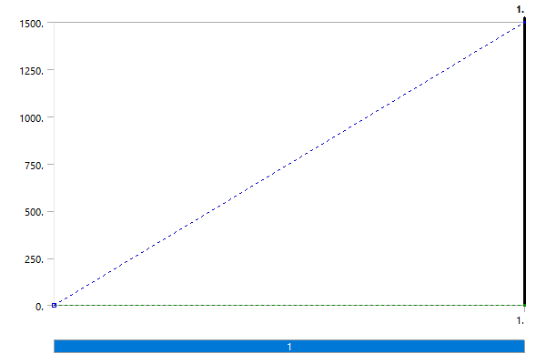

***Solution (A6)***

**TABLE 12  
Model (A4) > Static Structural (A5) > Solution**

|  |  |
| --- | --- |
| Object Name | *Solution (A6)* |
| State | Solved |
| **Adaptive Mesh Refinement** | |
| Max Refinement Loops | 1. |
| Refinement Depth | 2. |
| **Information** | |
| Status | Done |
| MAPDL Elapsed Time | 3. s |
| MAPDL Memory Used | 193. MB |
| MAPDL Result File Size | 2.625 MB |
| **Post Processing** | |
| Beam Section Results | No |
| On Demand Stress/Strain | No |

**TABLE 13  
Model (A4) > Static Structural (A5) > Solution (A6) > Solution Information**

|  |  |
| --- | --- |
| Object Name | *Solution Information* |
| State | Solved |
| **Solution Information** | |
| Solution Output | Solver Output |
| Newton-Raphson Residuals | 0 |
| Identify Element Violations | 0 |
| Update Interval | 2.5 s |
| Display Points | All |
| **FE Connection Visibility** | |
| Activate Visibility | Yes |
| Display | All FE Connectors |
| Draw Connections Attached To | All Nodes |
| Line Color | Connection Type |
| Visible on Results | No |
| Line Thickness | Single |
| Display Type | Lines |

**TABLE 14  
Model (A4) > Static Structural (A5) > Solution (A6) > Results**

|  |  |  |
| --- | --- | --- |
| Object Name | *Equivalent Stress* | *Total Deformation* |
| State | Solved | |
| **Scope** | | |
| Scoping Method | Geometry Selection | |
| Geometry | All Bodies | |
| **Definition** | | |
| Type | Equivalent (von-Mises) Stress | Total Deformation |
| By | Time | |
| Display Time | Last | |
| Separate Data by Entity | No | |
| Calculate Time History | Yes | |
| Identifier |  | |
| Suppressed | No | |
| **Integration Point Results** | | |
| Display Option | Averaged |  |
| Average Across Bodies | No |  |
| **Results** | | |
| Minimum | 1147. Pa | 0. m |
| Maximum | 1.1995e+007 Pa | 3.8672e-006 m |
| Average | 6.5346e+005 Pa | 1.0805e-006 m |
| Minimum Occurs On | Spur Gear | |
| Maximum Occurs On | Spur Gear | |
| **Information** | | |
| Time | 1. s | |
| Load Step | 1 | |
| Substep | 1 | |
| Iteration Number | 1 | |
|  |  | |

**FIGURE 2  
Model (A4) > Static Structural (A5) > Solution (A6) > Equivalent Stress**

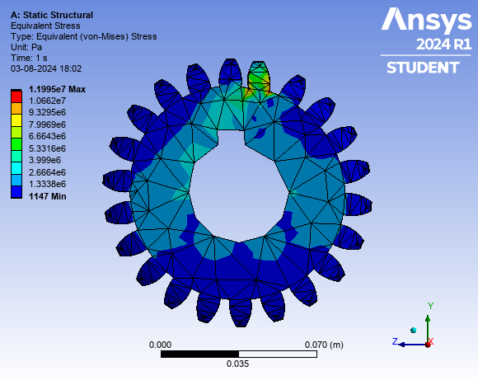

**TABLE 15  
Model (A4) > Static Structural (A5) > Solution (A6) > Equivalent Stress**

|  |  |  |  |
| --- | --- | --- | --- |
| Time [s] | Minimum [Pa] | Maximum [Pa] | Average [Pa] |
| 1. | 1147. | 1.1995e+007 | 6.5346e+005 |

**FIGURE 3  
Model (A4) > Static Structural (A5) > Solution (A6) > Total Deformation**

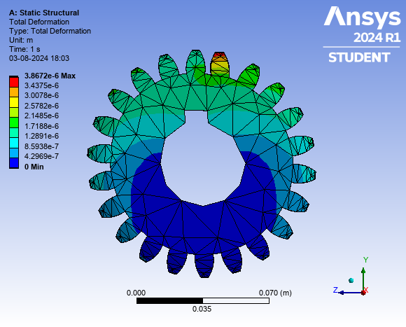

**TABLE 16  
Model (A4) > Static Structural (A5) > Solution (A6) > Total Deformation**

|  |  |  |  |
| --- | --- | --- | --- |
| Time [s] | Minimum [m] | Maximum [m] | Average [m] |
| 1. | 0. | 3.8672e-006 | 1.0805e-006 |

**Material Data**

***Structural Steel***

**TABLE 17  
Structural Steel > Constants**

|  |  |
| --- | --- |
| Density | 7850 kg m^-3 |
| Coefficient of Thermal Expansion | 1.2e-005 C^-1 |
| Specific Heat | 434 J kg^-1 C^-1 |
| Thermal Conductivity | 60.5 W m^-1 C^-1 |
| Resistivity | 1.7e-007 ohm m |

**TABLE 18  
Structural Steel > Color**

|  |  |  |
| --- | --- | --- |
| Red | Green | Blue |
| 132 | 139 | 179 |

**TABLE 19  
Structural Steel > Compressive Ultimate Strength**

|  |
| --- |
| Compressive Ultimate Strength Pa |
| 0 |

**TABLE 20  
Structural Steel > Compressive Yield Strength**

|  |
| --- |
| Compressive Yield Strength Pa |
| 2.5e+008 |

**TABLE 21  
Structural Steel > Tensile Yield Strength**

|  |
| --- |
| Tensile Yield Strength Pa |
| 2.5e+008 |

**TABLE 22  
Structural Steel > Tensile Ultimate Strength**

|  |
| --- |
| Tensile Ultimate Strength Pa |
| 4.6e+008 |

**TABLE 23  
Structural Steel > Isotropic Secant Coefficient of Thermal Expansion**

|  |
| --- |
| Zero-Thermal-Strain Reference Temperature C |
| 22 |

**TABLE 24  
Structural Steel > S-N Curve**

|  |  |  |
| --- | --- | --- |
| Alternating Stress Pa | Cycles | Mean Stress Pa |
| 3.999e+009 | 10 | 0 |
| 2.827e+009 | 20 | 0 |
| 1.896e+009 | 50 | 0 |
| 1.413e+009 | 100 | 0 |
| 1.069e+009 | 200 | 0 |
| 4.41e+008 | 2000 | 0 |
| 2.62e+008 | 10000 | 0 |
| 2.14e+008 | 20000 | 0 |
| 1.38e+008 | 1.e+005 | 0 |
| 1.14e+008 | 2.e+005 | 0 |
| 8.62e+007 | 1.e+006 | 0 |

**TABLE 25  
Structural Steel > Strain-Life Parameters**

|  |  |  |  |  |  |
| --- | --- | --- | --- | --- | --- |
| Strength Coefficient Pa | Strength Exponent | Ductility Coefficient | Ductility Exponent | Cyclic Strength Coefficient Pa | Cyclic Strain Hardening Exponent |
| 9.2e+008 | -0.106 | 0.213 | -0.47 | 1.e+009 | 0.2 |

**TABLE 26  
Structural Steel > Isotropic Elasticity**

|  |  |  |  |  |
| --- | --- | --- | --- | --- |
| Young's Modulus Pa | Poisson's Ratio | Bulk Modulus Pa | Shear Modulus Pa | Temperature C |
| 2.e+011 | 0.3 | 1.6667e+011 | 7.6923e+010 |  |

**TABLE 27  
Structural Steel > Isotropic Relative Permeability**

|  |
| --- |
| Relative Permeability |
| 10000 |